Alex Arnold
Professor Torres
2/27/25
IT 120-41198
Lab5

Part A: Netlab1Security+ V3Links to an external site.
Log onto the Netlab environment and attempt to locate "ALL" accounts on "ALL" systems (except Kali)
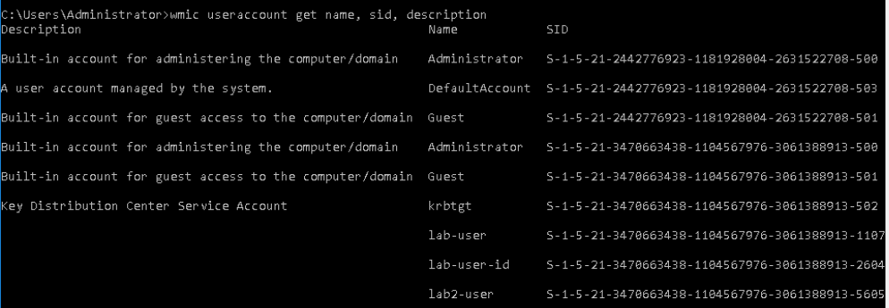
Win 16 machine The only active Local account on the system is the Administrator account. Administrator, lab-user and lab2-user are all domain accounts hosted on Win12R2. (iis on the system uses basic authentication)
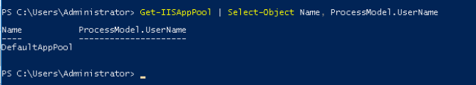
Win16 machine while running IIS has no accounts
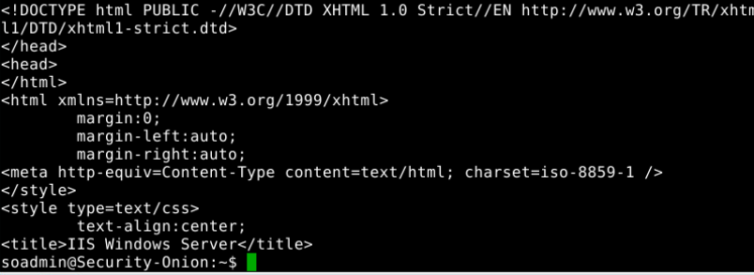
iis has one website running
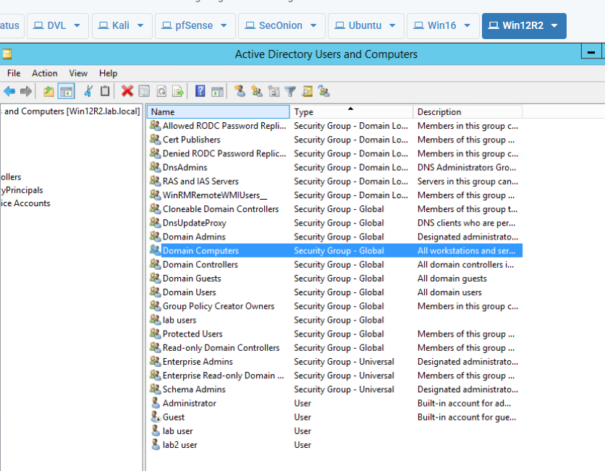
Win12R2 has many security group accounts on the Lab domain but only 4 user accounts
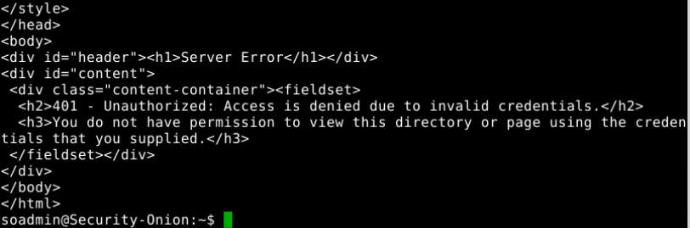
Win 2k12 has valid website with credentials
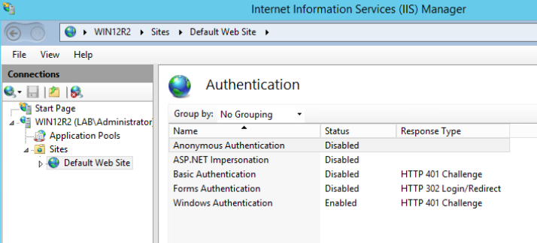
iis was set to Anonymous Authentication. I changed to windows authentication and disabled the previous method

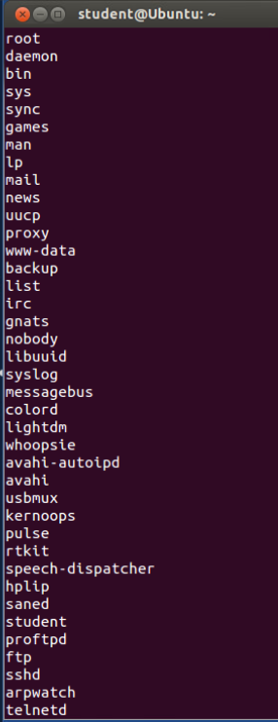
All accounts on the Ubuntu system though student, nobody, and root are the only main accounts that would be used. The others are all service accounts

Ubuntu non system users are nobody (pseudo user) and student
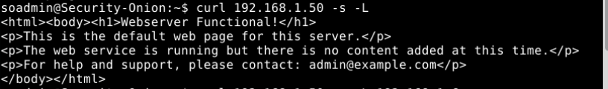
Ubuntu is running defaultweb server with no content
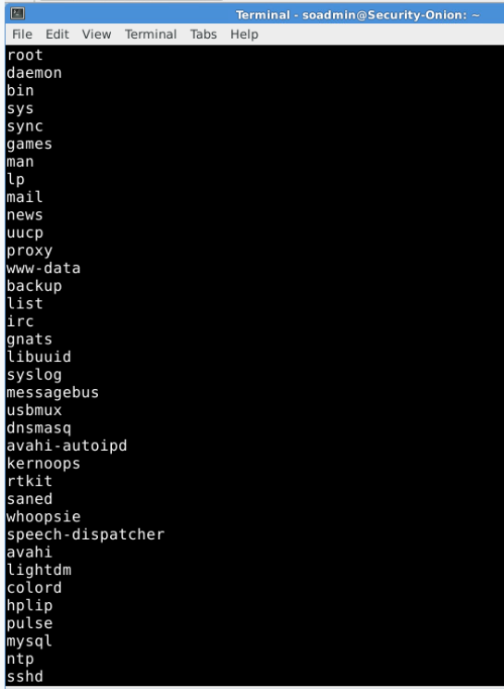
All accounts on the security onion machine
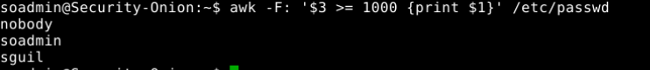
Security onion non system user accounts nobody (Pseudo account) soadmin (user account) and sguil (dedicated user account tied to Sguil interface network analyser)
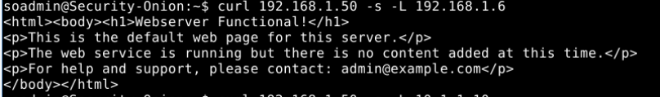
Running fefault web server witn no content
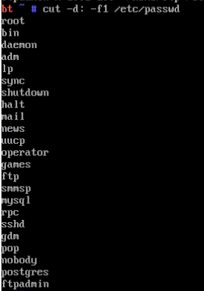
All accounts on DVL

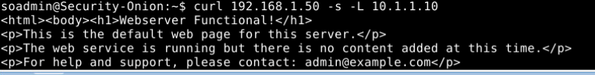
DVL is running the default webserver with no content
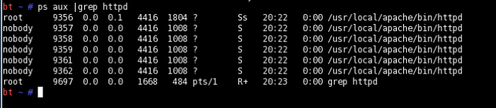
however you can staart the HTTPD process using the desktop icon and it will start 6 virtual hosts
Postgres and ftpadmin are the only non system user accounts
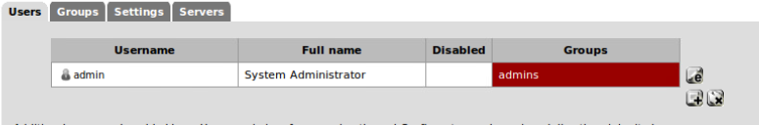
Only the Admin account is on pfsense

Change the password on "all" accounts
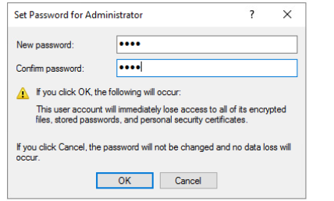
Changing win16 machine Local Admin account pw
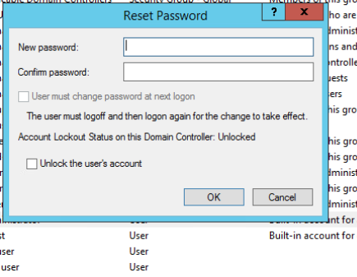
Changing the pw on the Win12R2 accounts
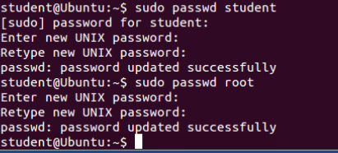
Changing pw on Ubuntu
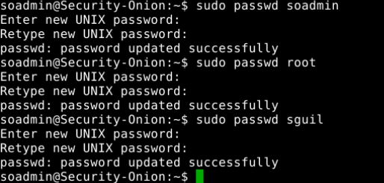
Changing passwords on Security onion
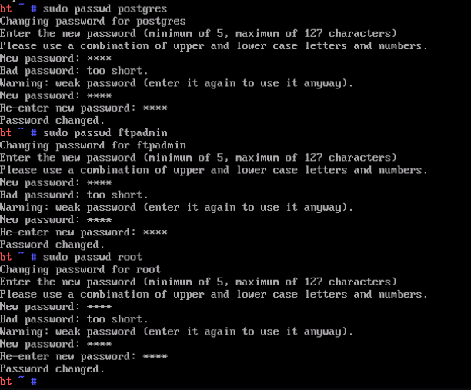
Changing password on DVL
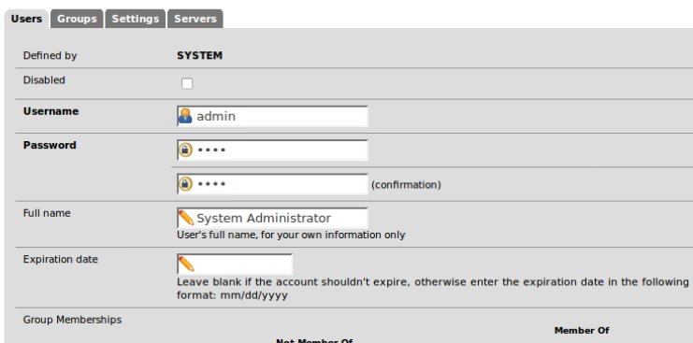
Changing password on pfsense

All accounts should have only 1 admin account, and 1 user account.
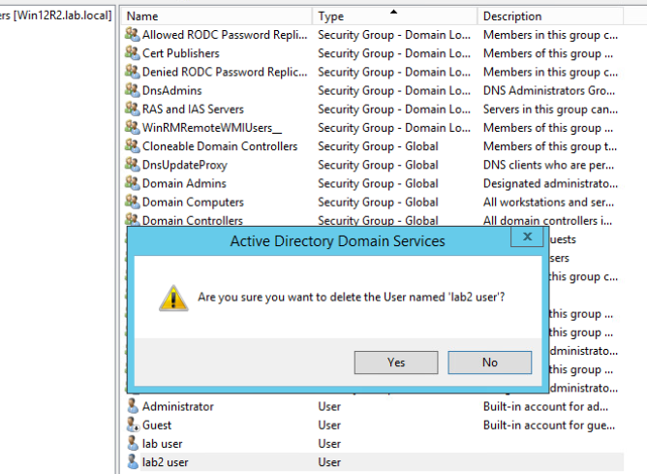
Deleting the lab 2 user account to ensure there is one admin and one user account

Part B:
Sign up for a free account at: https://www.hacksplaining.com/lessons (Links to an external site.)
this website explains the top 10 in detail
There are 25 links explaining the top 10 in lab format.
Do ANY 10 of the links, and screenshot your final page showing completion of at least 10 labs. If you do all 25, you will receive an extra 5 points of extra credit.
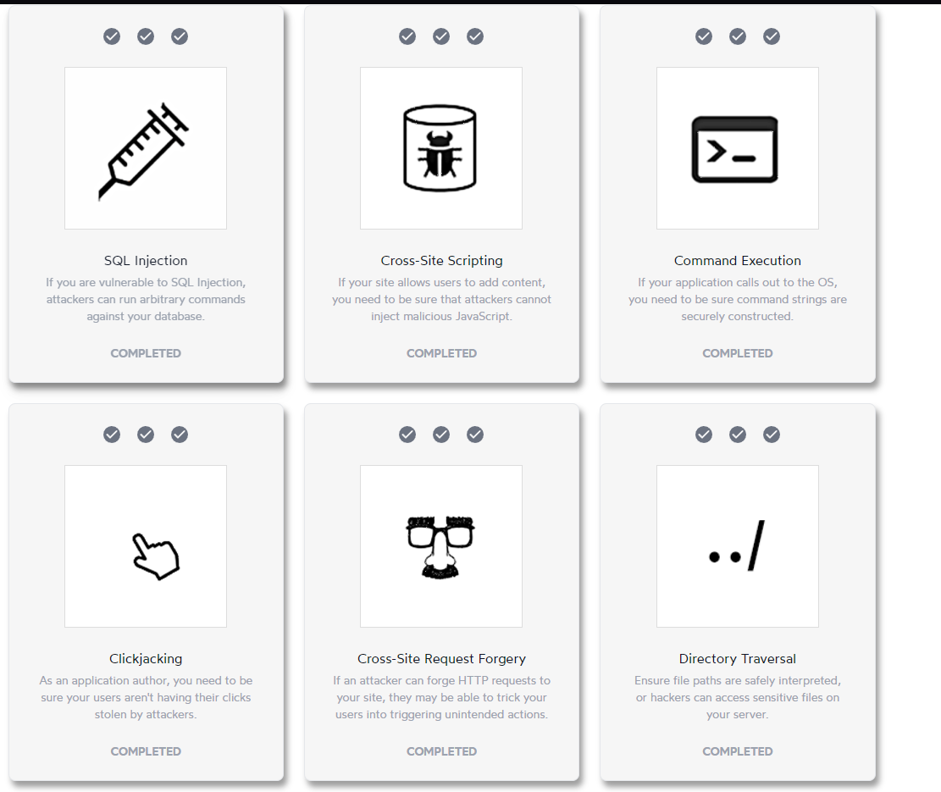
First 6 completed
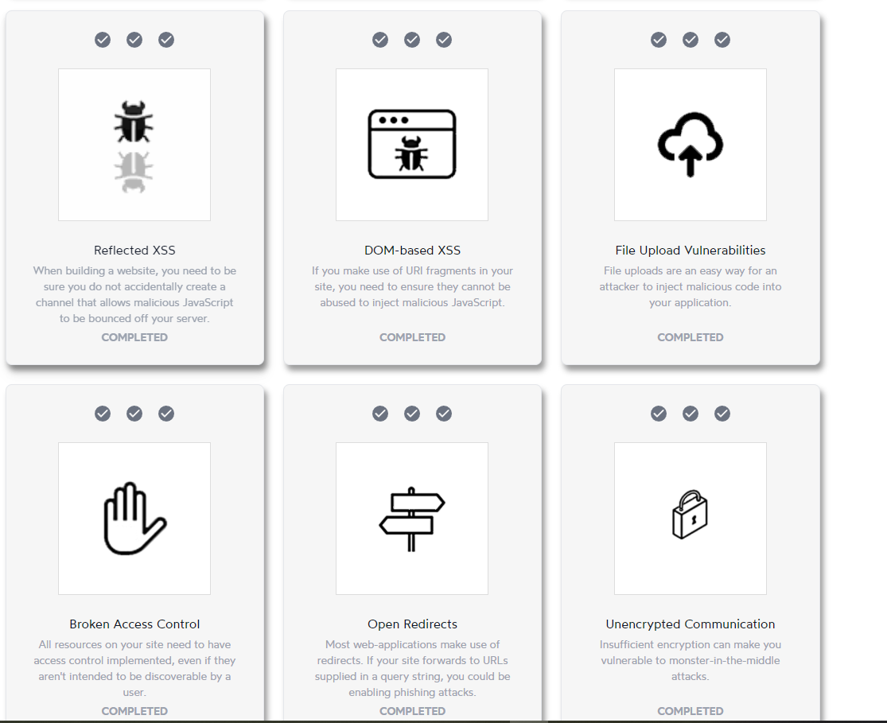
6-12 completed
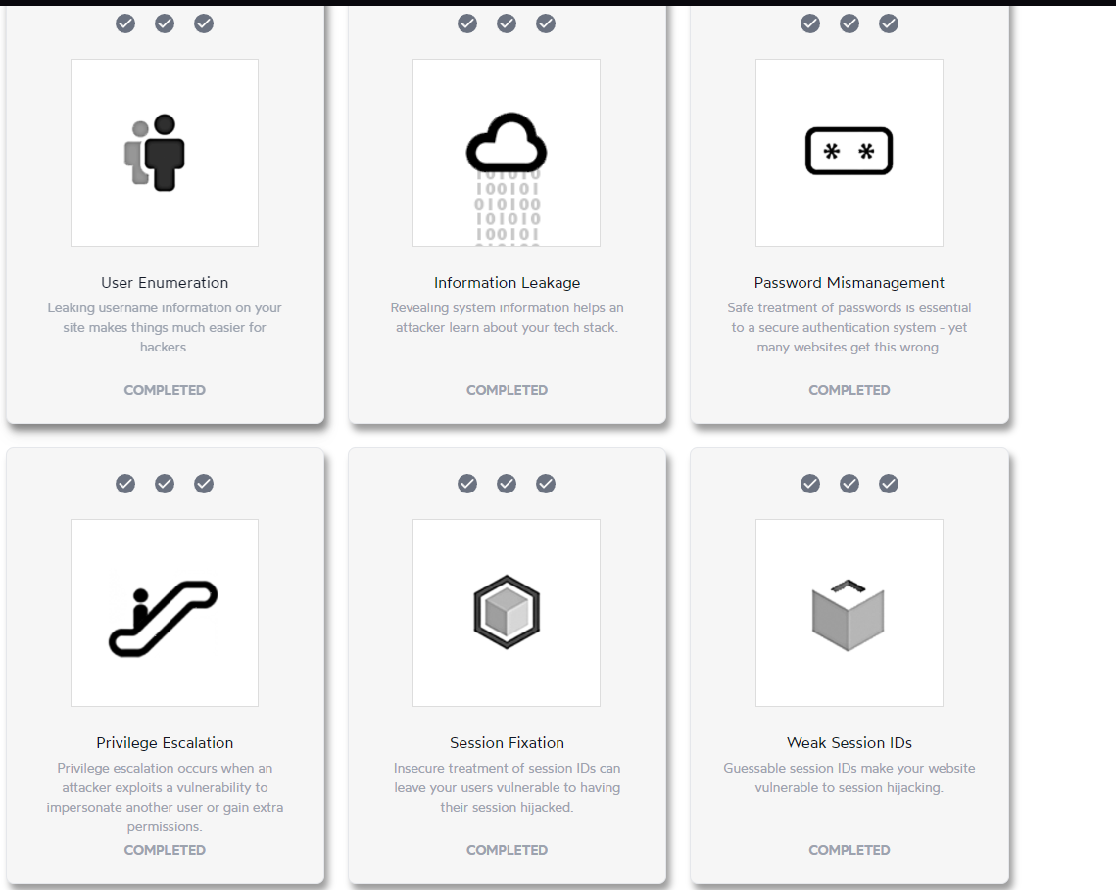
12-18 completed
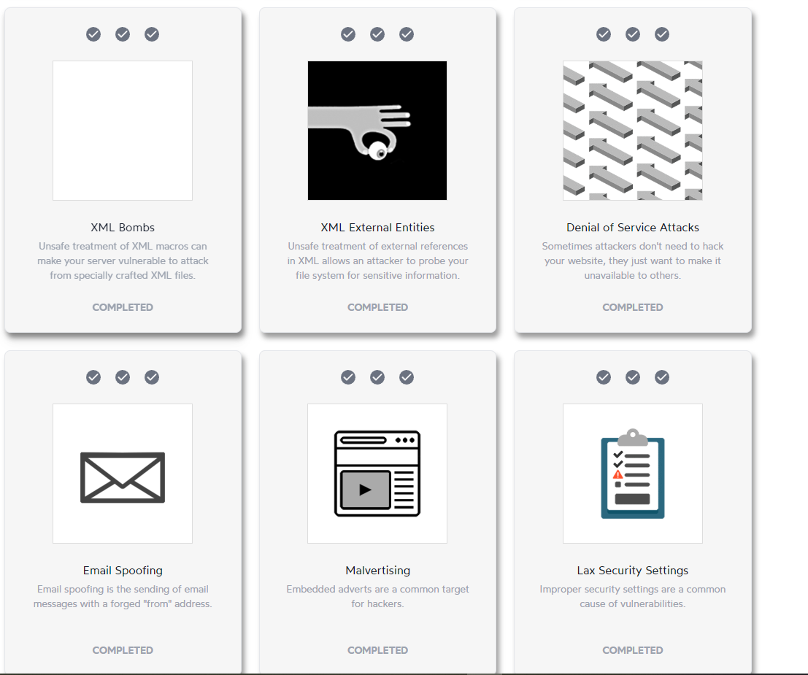
19-24 completed
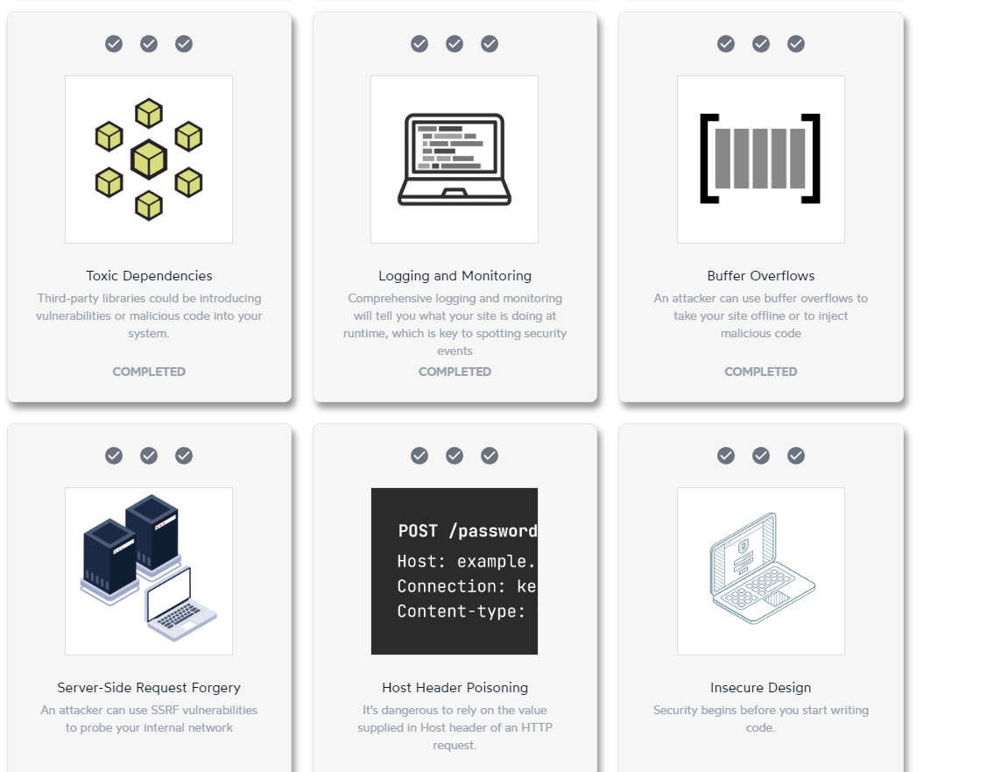
25-30 completed
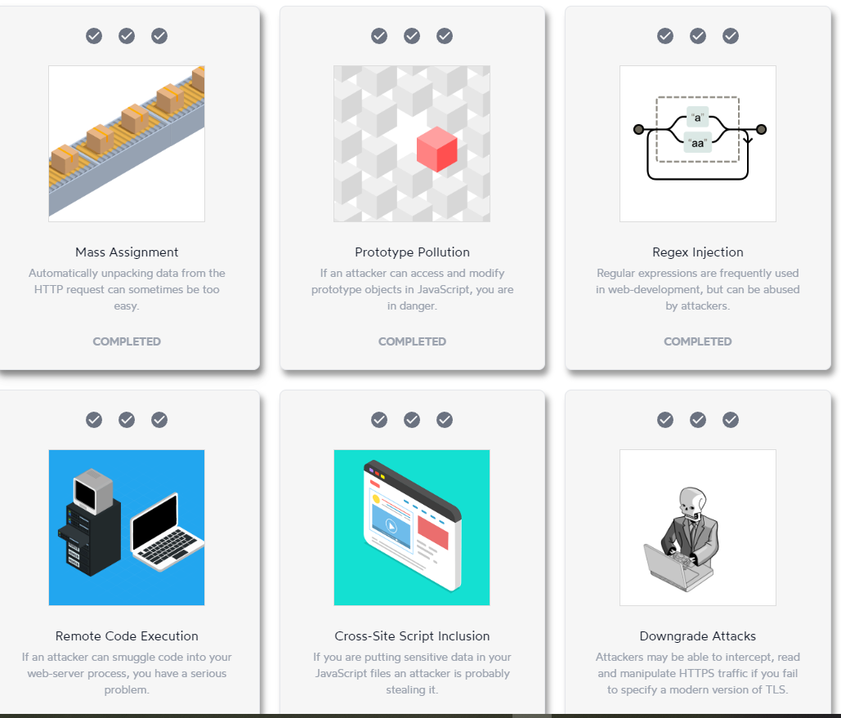
31-36 completed
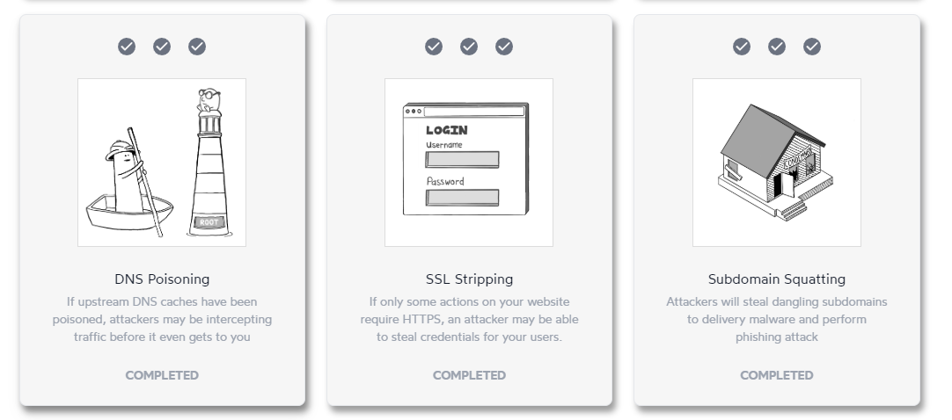
37-39 completed


Part C:
Discuss each section of the OWASP top 10, how are they exploited and how do you protect against it.
A01:2021-Broken Access Control
Exploit:
- Insecure Direct Object References such as having the profile ID at the end of a url string and allowing users to modify the string. (thus allowing access to other users profiles)
- Missing access control – In essence, the api does not enforce user permissions allowing regular users to access an admin only api
- Misconfigured Cross-Origin Resource Sharing allowing 3rd party origins to access an api (that shouldn’t be publicly accessible)
- Privilege Escalation – a normal user modifies their request to gain access to admin privileges
Protection:
- Enforce Proper Authorization Checks – server side access controls for all requests
- Secure Direct Object References – always verify user permissions before gaining access
- Restrict API & Function Access – ensure that users have proper authorization for back-end services
- Harden CORS Policies – ensure that origins are from trusted domains

A02:2021-Cryptographic Failures
Exploit:
- Using Weak or Outdated Encryption Algorithms – using weak or outdated encryption algorithms allowing hackers to decrypt sensitive data
- Insecure Key Management – such as leaving an API key in a github repository allowing access
- Hardcoded Credentials – similar to the above but having users and pw coded into the website or code
Protection:
- Using Weak or Outdated Encryption Algorithms – use stronger encryption with salting and or peppering of things like pw to make them harder to decrypt
- Insecure Key Management – use some form of key management and sanitize git repositories
- Hardcoded Credentials – store credentials securely in environment variables or don’t hard code if possible

A03:2021-Injection
Exploit:
- SQL Injection - Unsanitized input used in SQL queries.
- Cross-Site Scripting (XSS) – User input is rendered in HTML without proper escaping
- Command Injection - execution of commands from untrusted user inputs

Protection:
- SQL Injection – use parameterized queries to prevent entries from being seen as code and use least privilege when giving rights to accounts
- Cross-Site Scripting (XSS) – use escape commands, content security policy, validate and sanitize inputs
- Command Injection – use APIs to process user inputs/ allow only expected inputs, use least privilege when running applications

A04:2021-Insecure Design
Exploit:
- Missing Rate Limiting & API Abuse – missing the rate limiting can allow users to automate the process of brute forcing passwords
- Predictable Identifiers & Insecure Object References – things like using incrementing transaction ids can allow users to access other transactions
- Weak Multi-Factor Authentication (MFA) Implementation – re use of non expiring one time passwords can allow replay attacks
- Insecure Default Configurations – using default credentials on web facing devices / services

Protection:
- Missing Rate Limiting & API Abuse – using rate limiting or CAPTCHA can delay or limit the speed of attempts
- predictable Identifiers & Insecure Object References – access control checks and UUIDs instead of sequential ID’s
- Weak Multi-Factor Authentication (MFA) Implementation – expire OTP after use
- Insecure Default Configurations – changing to non-default passwords

A05:2021-Security Misconfiguration
Exploit:
- Default or Weak Credentials - using default credentials on web facing devices / services
- Unpatched Software & Outdated Components – such as wordpress running an outdated software vulnerable to RCE
- Improper CORS Configuration – webpages allowing 3rd party origin (or orphaned subdomains) requests
- Directory Listing Enabled – listing directories / file paths in the url.

Protection:
- Default or Weak Credentials - changing to non-default passwords
- Unpatched Software & Outdated Components – patching and updating systems regularly
- Improper CORS Configuration – Avoiding wildcard entries in the origin file and ensuring that only approved domains / subdomains are allowed access
- Directory Listing Enabled - disable or obfuscate the file path of the website to avoid directory traversal

A06:2021-Vulnerable and Outdated Components
Exploit:
- Using Unpatched or Outdated Software – old software can have known vulnerabilities that can be found on the web such as remote code execution making exploitation easier.
- Dependencies with Known Vulnerabilities – use of non updated libraries that can allow users to manipulate data.
- End-of-Life (EOL) Software – EOL software no longer gets security updates and will have a list of known vulnerabilities to be exploited
- Outdated JavaScript Libraries - old versions have known vulnerabilities such as cross site scripting attacks.

Protection:
- Using Unpatched or Outdated Software – update and patch software
- Dependencies with Known Vulnerabilities – using package management software to ensure packages are updated
- End-of-Life (EOL) Software – migrated to supported versions or extend support services
- Outdated JavaScript Libraries - regularly checking for updates and installing them

A07:2021-Identification and Authentication Failures
Exploit:
- Weak or Default Credentials – default credentials can be found online for many devices giving hackers easy access to systems
- Credential Stuffing & Brute Force Attacks - hackers using leaked credentials to brute force access
- Exposed Authentication Endpoints – api allows unauthenticated users to check if an email is registered via automated response such as password incorrect and email incorrect vs incorrect email or password
- Insecure Password Reset Mechanisms – non expiring reset links allowing for reuse at a later time

Protection:
- Weak or Default Credentials – use complex passwords that meet a minimum strength requirement
- Credential Stuffing & Brute Force Attacks – rate limiting and mfa
- Exposed Authentication Endpoints - supply error messages that do not provide useful feedback for information gathering such as incorrect username or password instead of stating one or the other
- Insecure Password Reset Mechanisms – make links one time use

A08:2021-Software and Data Integrity Failures
Exploit:
- Insecure Software Updates – installing updates without verifying authenticity (connecting over http vs https allowing for man in the middle attacks)
- Deserialization Attacks - A Java application deserializes user-supplied objects, allowing an attacker to execute arbitrary code.
- Data Integrity Failures in Database Transactions - allowing things such as negative balance transactions in a banking system enabling manipulation

Protection:
- Insecure Software Updates – using signed updates to ensure authenticity
- Deserialization Attacks – using safe formats such as JASON and implementing allow lists for deserialization
- Data Integrity Failures in Database Transactions – using strong validation and integrity checks for sensitive data

A09:2021-Security Logging and Monitoring Failures
Exploit:
- Missing or Insufficient Logging – not logging multiple failed login attempts allowing a brute force attack to go unnoticed
- Logging Sensitive Data – storing plaintext information such as credit card numbers, user IDs, api keys and so on that could be compromised
- No Real-Time Monitoring or Alerting – an attacker using an exploitation / vulnerability over the course of weeks to exfiltrate data goes unnoticed without real time alerts or active monitoring
- Lack of Forensic Capabilities - ddos attack happens but the logs don’t capture a source ip or request payload or a compromised account is not logged performing actions it should not (allowing for later use)

Protection:

- Missing or Insufficient Logging – Log all authentication events, privilege changes, and data modifications.
- Logging Sensitive Data – mask or encrypt sensitive data (also including salting or peppering to make data harder to crack)
- No Real-Time Monitoring or Alerting – setting up alerts and real time monitoring to be alerted to events that are out of the ordinary
- Lack of Forensic Capabilities – enable detailed logging and retain logs for an appropriate amount of time

A10:2021-Server-Side Request Forgery
Exploit:
- Accessing Internal Systems - Attacker can access internal systems or cloud metadata services via a modified web app fetch request
- Bypassing Firewalls – making the webserver make a request on behalf of the user with higher permissions than the user has
- Port Scanning Internal Networks - https://example.com/fetch?url=http://internal-server:22 or such a command to scan available ports in an internal network

Protection:
- Accessing Internal Systems - Restrict requests to a safe allowlist of external domains and block access to internal ip ranges
- Bypassing Firewalls – deny requests to internal ips and use segmentation to create a DMZ in the network for web facing systems
- Port Scanning Internal Networks – restrict outbound requests and trusted domains as well as implementing response filtering.

